Task 3 :

Algorithm   
  
we suppose to detect the length of the Canon and 3 diameter.

Giving: the width, height and the length of the brick

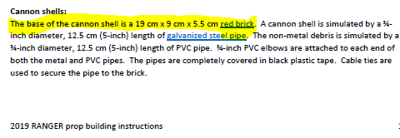

**NOTE: CHECK THE FINAL DIMINSION AGAIN**

Same as mission 1   
pixel count and calculating the length of the single pixel and multiply it by the numb of pixel of the length desired.

* The difference from the first task
  + - The plane of the desired length that I want to measure is different from the reference plane.
    - So the pixel length will give an error between 2:8 cm
    - We concord it by a list that contain all standard PVC’s diameter.
    - We need 3 screenshots to calculate the length and the 3 diameter

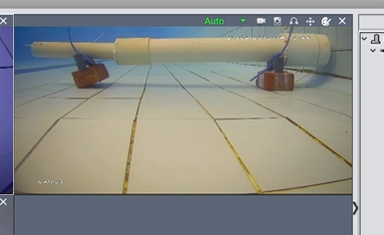The first screen shots

Side View for the canon

From this we will find the 2 diameter D1, D3.

(R1,R3)

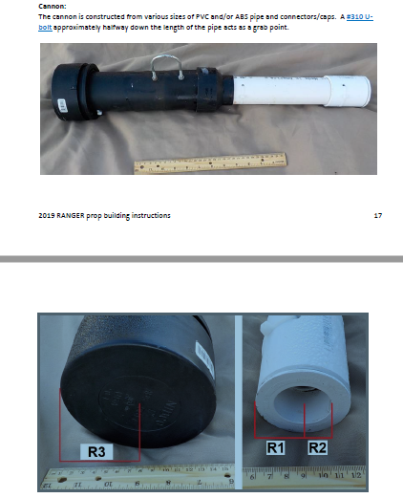

The second screen shots

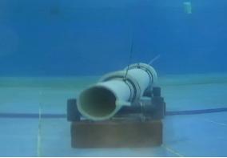

Elevation View

To calculate The inner diameter D2 (R2)

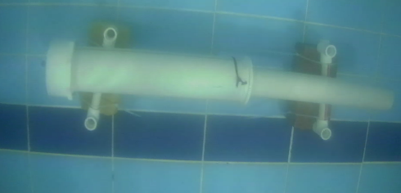The third screen shots

Plane view

To calculate the lengh

Steps to run the code :  
  
Open the folder as Edit with IDLE

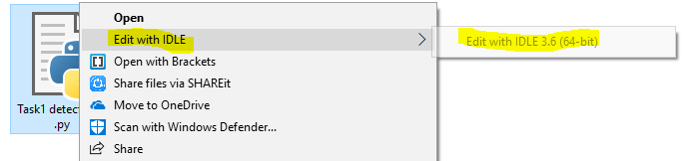

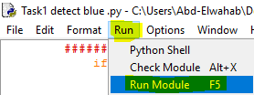

Run > Run module   
OR  
F5

Now we will find two half of the screen

We will draw on the right one…

First press n

And determine the true length of the reff (brick)



We will choose the Hight  
5.5

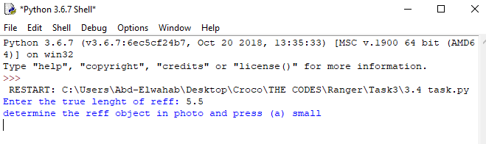

Then we draw 2 point  
that define a line that define the 5.5 cm reff  
then we press a

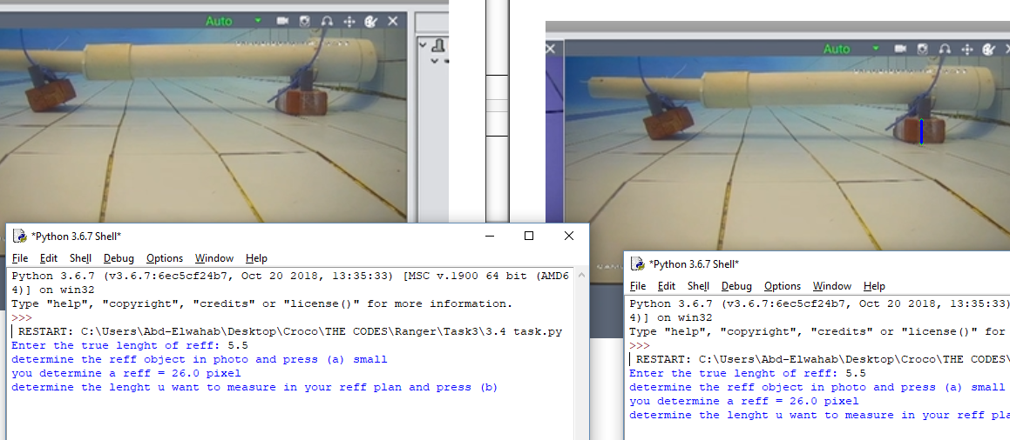

Then we determine the diameter that lies above of the reff crack

Then press ‘o’

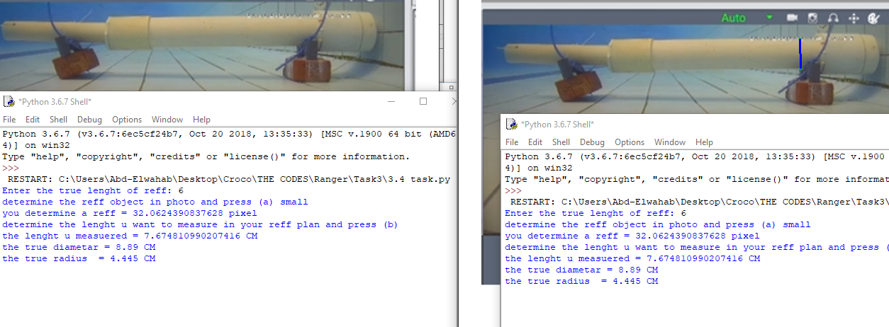

Then we will get the right pvc D3

By selecting it and check ‘O’ again

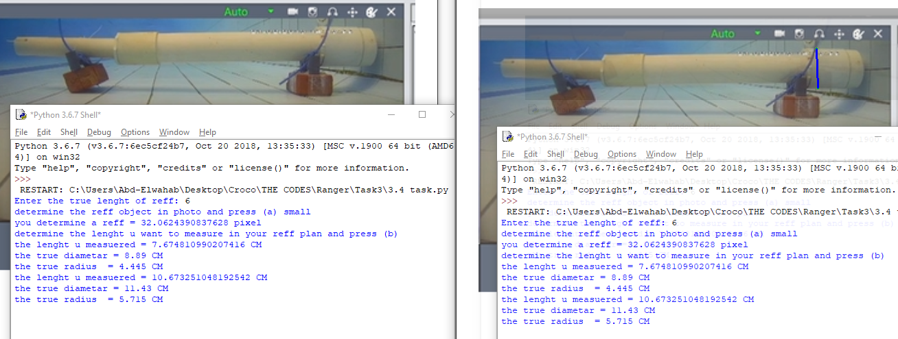

Then select the right end and ‘C’ to add the cap (.4 + .4)  
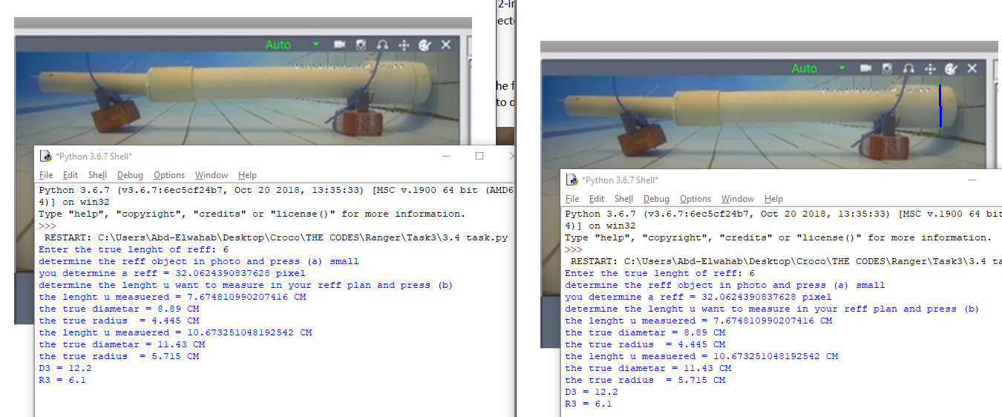

By the same way we get the left end

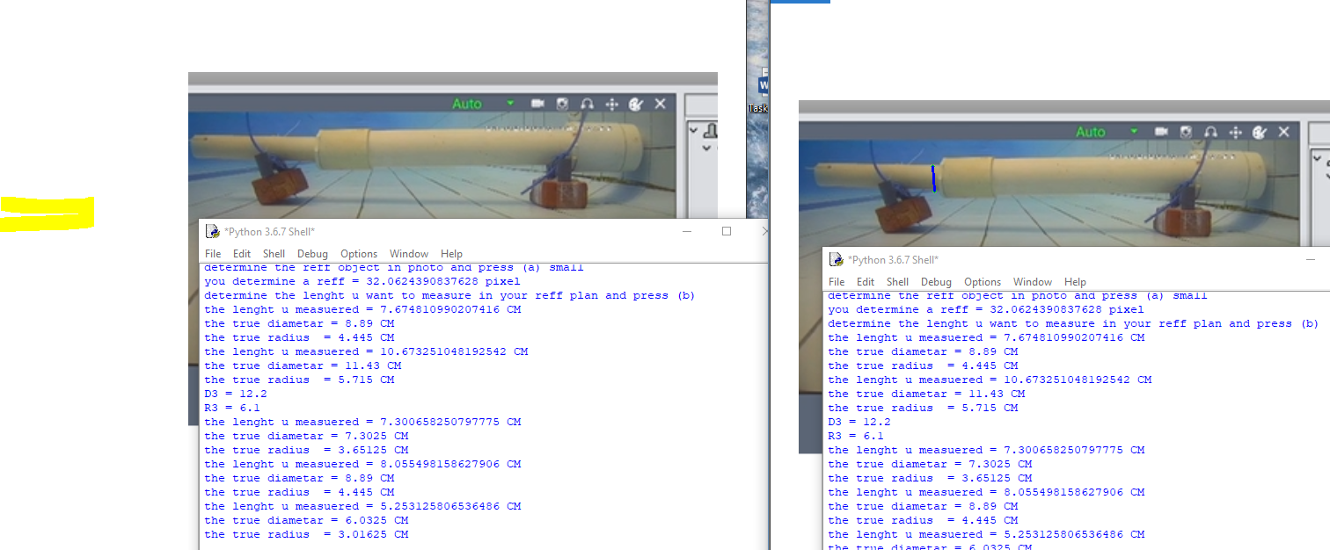

Then ‘I’ to add the cap (.4+.4)  
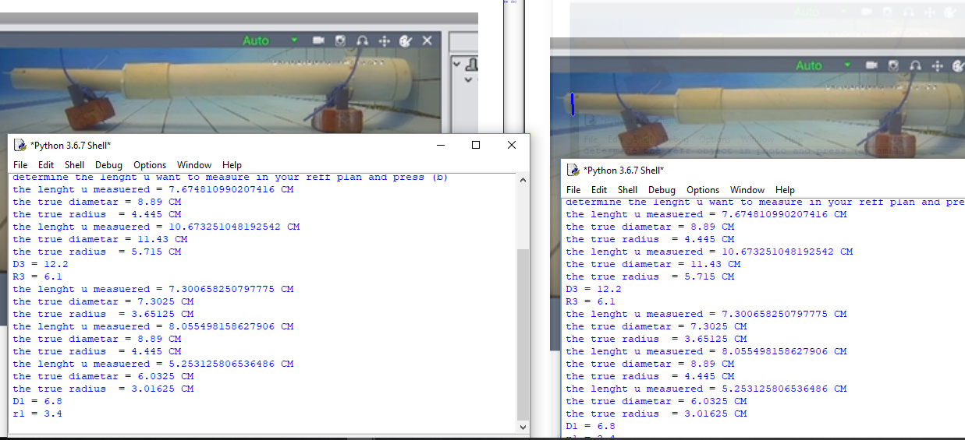

then the second photo

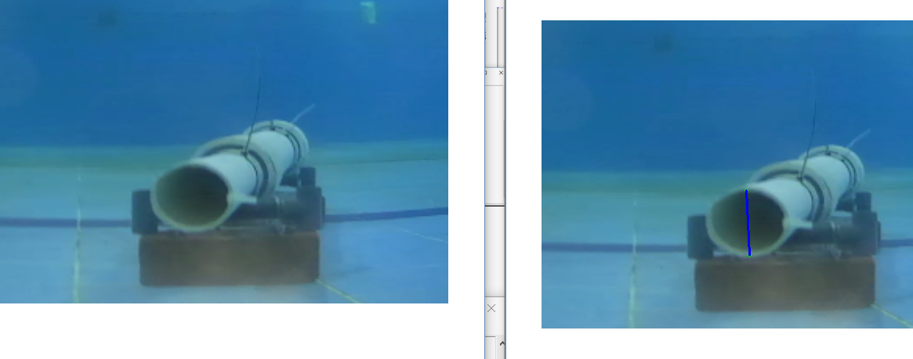

We click ‘n’ = D1

Then select D1

And ‘a’

OR  
click ‘n’ = the height of the brick

Then ‘a’

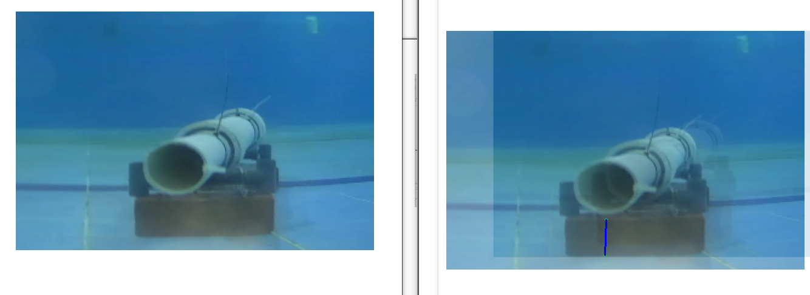

After the first method select the inner diameter and click ‘h’

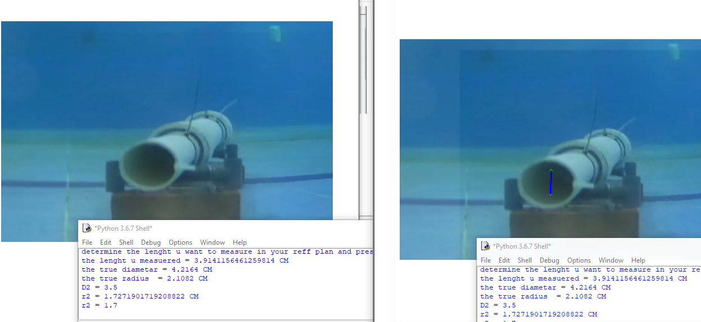

Same for the length (I have no photo to it)  
select

* ‘n’ = the width of the brick
* select that width
* click ‘a’
* determine the end and start point of the canon
* click ‘d’

I d1

H d2

C d3

D length